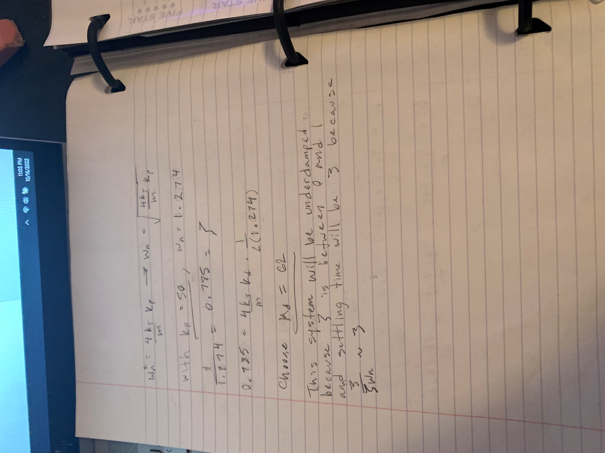

Plots for part a:

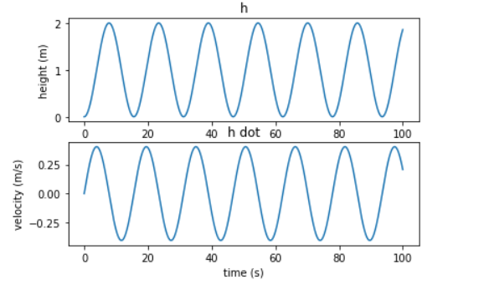

Kp = 15:

Kp = 50:

Code for part a:

import numpy

import matplotlib.pyplot as plt

from scipy.integrate import solve_ivp

kt = 5.276 * 10 ** -4

m = 0.065

g = 9.81

Kp = 15

def x_dot(t, x):

    return [x[1], 4*kt*Kp/m - 4*kt*Kp*x[0]/m]

t = numpy.linspace(0, 100, 1000)

solution = solve_ivp(x_dot, [0, t[-1]], [0, 0], t_eval=t, vectorized=True)

t = solution['t']

h = solution['y'][0]

h_dot = solution['y'][1]

fig, ah = plt.subplots(2)

ah[0].plot(t, h)

ah[0].set_xlabel('time (s)')

ah[0].set_ylabel('height (m)')

ah[0].set_title('h')

ah[1].plot(t, h_dot)

ah[1].set_xlabel('time (s)')

ah[1].set_ylabel('velocity (m/s)')

ah[1].set_title('h dot')

plt.show()

The plots show that a higher Kp value results in more frequent oscillations around the reference point. This would indicate that the control responds more quickly to a displacement and continues to overcompensate.

Plots for part b:

Code for part b:

Code for plotting:

import numpy

import matplotlib.pyplot as plt

from scipy.integrate import solve_ivp

kt = 5.276 * 10 ** -4

m = 0.065

g = 9.81

Kp = 1000

Kd = 62

def x_dot(t, x):

    return [x[1], 4*kt*Kp/m - 4*kt*Kp*x[0]/m - 4*kt*Kd*x[1]/m]

t = numpy.linspace(0, 10, 1000)

solution = solve_ivp(x_dot, [0, t[-1]], [0, 0], t_eval=t, vectorized=True)

t = solution['t']

h = solution['y'][0]

h_dot = solution['y'][1]

fig, ah = plt.subplots(2)

ah[0].plot(t, h)

ah[0].set_xlabel('time (s)')

ah[0].set_ylabel('height (m)')

ah[0].set_title('h')

ah[1].plot(t, h_dot)

ah[1].set_xlabel('time (s)')

ah[1].set_ylabel('velocity (m/s)')

ah[1].set_title('h dot')

plt.show()

Code for finding Kp and Kd:

The system is underdamped because the damping ratio (zeta) is between zero and one. The plots show this is the case as there is an oscillation around the reference point before the control finally settles.

Plots for part c:

Code for part c:

Code for plotting (after tuning):

import numpy

import matplotlib.pyplot as plt

from scipy.integrate import solve_ivp

kt = 5.276 * 10 ** -4

m = 0.065

g = 9.81

Kp = 5

Kd = 62

def x_dot(t, x):

    return [x[1], 4*kt*Kp/m - 4*kt*Kp*x[0]/m - 4*kt*Kd*x[1]/m]

t = numpy.linspace(0, 100, 1000)

solution = solve_ivp(x_dot, [0, t[-1]], [0, 0], t_eval=t, vectorized=True)

t = solution['t']

h = solution['y'][0]

h_dot = solution['y'][1]

fig, ah = plt.subplots(2)

ah[0].plot(t, h)

ah[0].set_xlabel('time (s)')

ah[0].set_ylabel('height (m)')

ah[0].set_title('h')

ah[1].plot(t, h_dot)

ah[1].set_xlabel('time (s)')

ah[1].set_ylabel('velocity (m/s)')

ah[1].set_title('h dot')

plt.show()

Code for finding Kp and Kd:

This system is overdamped because the damping ratio (zeta) is greater than one. This is shown in the plots as the control takes a much slower ascent to the reference point.

Part d:

Plots:

Before adding Ki:

After adding Ki:

The plots show that before adding the I control, there is some difference between the expected control and the actual control (with uncertainty). After adding in the I control, this uncertainty is eliminated and the two overlap.

Code:

Before adding Ki:

import numpy

import matplotlib.pyplot as plt

from scipy.integrate import solve_ivp

kt = 5.276 * 10 ** -4

m = 0.065

g = 9.81

Kp = 1000

Kd = 62

ucty = 0.95 #uncertainty for actuators

def x_dot_B(t, x):

    return [x[1], 4*kt*Kp/m - 4*kt*Kp*x[0]/m - 4*kt*Kd*x[1]/m]

t = numpy.linspace(0, 10, 1000)

solutionB = solve_ivp(x_dot_B, [0, t[-1]], [0, 0], t_eval=t, vectorized=True)

t_B = solutionB['t']

h_B = solutionB['y'][0]

h_dot_B = solutionB['y'][1]

def x_dot_D(t, x):

    return [x[1], ucty*4*kt*Kp/m - ucty*4*kt*Kp*x[0]/m - ucty*4*kt*Kd*x[1]/m - 0.05]

solutionD = solve_ivp(x_dot_D, [0, t[-1]], [0, 0], t_eval=t, vectorized=True)

t_D = solutionD['t']

h_D = solutionD['y'][0]

h_dot_D = solutionD['y'][1]

overlapping = 1

fig, ah = plt.subplots(2)

ah[0].plot(t, h_B, color='blue', alpha=overlapping)

ah[0].set_xlabel('time (s)')

ah[0].set_ylabel('height (m)')

ah[0].set_title('h')

ah[1].plot(t, h_dot_B, color='blue', alpha=overlapping)

ah[1].set_xlabel('time (s)')

ah[1].set_ylabel('velocity (m/s)')

ah[1].set_title('h dot')

ah[0].plot(t, h_D, color='green', alpha=overlapping)

ah[0].set_xlabel('time (s)')

ah[0].set_ylabel('height (m)')

ah[0].set_title('h')

ah[1].plot(t, h_dot_D, color='green', alpha=overlapping)

ah[1].set_xlabel('time (s)')

ah[1].set_ylabel('velocity (m/s)')

ah[1].set_title('h dot')

plt.show()

After adding Ki:

import numpy

import matplotlib.pyplot as plt

from scipy.integrate import solve_ivp

kt = 5.276 * 10 ** -4

m = 0.065

g = 9.81

Kp = 1000

Kd = 62

Ki = 0

ucty = 0.95 #uncertainty for actuators

def x_dot_D_no_Ki(t, x):

    return [x[1], ucty*4*kt*Kp/m - ucty*4*kt*Kp*x[0]/m - ucty*4*kt*Kd*x[1]/m - 0.05]

t = numpy.linspace(0, 10, 1000)

solutionNoKi = solve_ivp(x_dot_D_no_Ki, [0, t[-1]], [0, 0], t_eval=t, vectorized=True)

t_B = solutionNoKi['t']

h_B = solutionNoKi['y'][0]

h_dot_B = solutionNoKi['y'][1]

def x_dot_D_with_Ki(t, x):

    return [x[1], ucty*4*kt*Kp/m + ucty*4*kt*Ki*x[2]/m - ucty*4*kt*Kd*x[1]/m - ucty*4*kt*Kp*x[0]/m - 0.05, 1 - x[0]]

solutionWKi = solve_ivp(x_dot_D_with_Ki, [0, t[-1]], [0, 0, 0], t_eval=t, vectorized=True)

t_D = solutionWKi['t']

h_D = solutionWKi['y'][0]

h_dot_D = solutionWKi['y'][1]

overlapping = 1

fig, ah = plt.subplots(2)

ah[0].plot(t, h_B, color='blue', alpha=overlapping)

ah[0].set_xlabel('time (s)')

ah[0].set_ylabel('height (m)')

ah[0].set_title('h')

ah[1].plot(t, h_dot_B, color='blue', alpha=overlapping)

ah[1].set_xlabel('time (s)')

ah[1].set_ylabel('velocity (m/s)')

ah[1].set_title('h dot')

ah[0].plot(t, h_D, color='red', alpha=overlapping)

ah[0].set_xlabel('time (s)')

ah[0].set_ylabel('height (m)')

ah[0].set_title('h')

ah[1].plot(t, h_dot_D, color='red', alpha=overlapping)

ah[1].set_xlabel('time (s)')

ah[1].set_ylabel('velocity (m/s)')

ah[1].set_title('h dot')

plt.show()

Plots for part k:

V(x):

Indicator function:

Phase portrait:

Level Sets:

